This Vision Card outlines the desired business outcome, context, problem and vision for your new project idea. The following questions will guide technical teams in providing ball-park T Shirt sizing for the proposal. If unsure, provide your best first draft — your Business Engagement Mobilisation Partner will help you refine this after submission.

Desired SMART Business Outcome
Business outcomes should be measurable changes in a business metric, within a set timescale, for a clear stakeholder, and aligned to one or more strategic goals for your business-unit e.g.
- Reduce sales cycle duration for B2B customers by 20% within 12 months, enabling faster revenue realisation and improved customer experience
- Increase ‘fix broadband fault in one contact’ rates from 55% to 85% by Q4 2027, reducing operational cost-to-serve and increasing customer satisfaction in our network
Proposed Title | Offline Fixed Retentions
Primary (SMART) Outcome statement | Vison, Discovery & Definition (Foundation)  - Establish an approved Release 1 solution within two months, with confirmed scope, design, costs, benefits and delivery timescales, supported by a complete artefact set to enable confident execution.  - Provide clear forward visibility on Releases 2 and 3 within one month, agreeing high-level scope and design and producing indicative costs, benefits and timelines to inform strategic planning and investment decisions.  - Accelerate overall delivery and de-risk the business case by initiating Release 1 development in parallel with Release 2/3 Discovery and Definition, ensuring R2/R3 data is available to validate assumptions and refine the business case.  - Secure Investment Committee funding approval through delivery of an updated Offline Fixed Retentions business case, with an agreed channel sequence, costs, benefits and roadmap.  - Note: see section 8 ‘Offline Fixed Retentions Plan’ for an outline of activities, artefacts and timeline.  Releases 1 – 3 (Business Outcomes to be refined following the Discovery/ Definition phases and broken down by Release):  - Deliver offline VM fixed-retention capability on a Digital Front End (DFE) migrating 100% of existing Voice agents by June/July 2027 to mitigate the risk of operating on an out-of-support platform and safeguard £151m of existing voice recontract revenue.  - Enable evidence‑led decisions through experimentation and test‑and‑learn, to validate impact and gather feedback before scaling.  - Unlock the ESA roadmap by decommissioning Discover by September 2027, following successful migration to DFE, delivering £3.2m in operating cost savings between 2027–2030.  - Extend RetainX (built on DFE) into Field Sales and Retail, creating new VM recontract channels and driving £16.9m in incremental EBITDA between 2027–2030, subject to rollout sequence and timing.
The above can be derived by answering the following questions:
What type of state change/improvement must the project deliver? | Build fixed retention capabilities in new ESA platform (RetainX) enabled within Voice, Field Sales and Retail channels  Contribute resources to existing DFE In-life squad to support/maintain platform  Migrate existing voice users from Discover to RetainX  Decommission Discover
In which business metric? | Reduce operating cost of VM fixed recontract platform  Increase revenue and reduce churn by creating new fixed retention channels in Field Sales and Retail  Protect existing voice revenue by mitigating risk of out of support platform
For which specific stakeholder or business user? (Primary outcome beneficiary) | Virgin Media Fixed customers who wish to recontract via offline channels  Customer Contact Voice Sales / Service, Field Sales and Retail Agents  CIO for platform support and maintenance
By how much? (Quantified amount or percentage is required) | Reduction in platform operating and license costs of £3.2M between 2027-2030  Increase in incremental revenue with an estimated £16.9M EBIDTA benefit across Field Sales & Retail between 2027-2030  Protection of existing voice revenue of £151M per year within the voice channel
What is the current value for this business metric? | Cost reduction based on the following:  - Current Pega Discover license costs for 2026/2027 and forecasts costs for 2028-2030  - Current Discover platform maintenance costs  Field Sales and Retail Fixed Recontract Revenue:  - Zero as not currently transacting today via these channels
Within what timeframe? | Business Case assumes the following timelines:  - Discovery/Definition: May to Jul-26  - Release 1 Voice: Jul-May 27  - Agent Migration & Decommission of Discover: May-Sep-27  - Release 2 Field Sales: Apr-Sep-27  - Release 3 Retail: Sep-27 to Apr-28
What strategic outcome does this support? | Build Trust - Competency - Fix Critical Journeys

Stakeholders
Proposer | Donna Carey / Moritz Pfeiffer
Sponsor | Killian Faughnan
Person accountable for the business outcome | Moritz Pfeiffer / Donna Carey (Product vision, strategy, roadmap and lifecycle)  Leon Vaughan (Domain Owner for the new platform)  James Brown (Commercial)  Matt Murdoch (Field Sales & Retail Benefits)
Finance Business Partner(s) | Rebecca Williams (Field Sales & Retail Benefits)  Jain Kooran Kallookkaran (Cost Reduction Benefits which were approved by Leon Vaughan, Domain Owner)  Dayna Freke (Voice, Ops)  Craig Garvey (Voice Revenue)  Note no voice benefits included in business case to date, to be determined during Discovery if additional Voice benefits can be realised.
Other stakeholders (Optional)
Only include if consulted to date. e.g., Legal, Regulatory, Insights, Care, Retail Ops.
Role | Name
Digital Front End Domain Owner | Leon Vaughan
Care & Voice Customer Digital EA | Kanchan Anand
Sales, Retentions, XSUS Customer Digital EA | Manish Dahiya
Digital Enterprise Architect | Kat Duncan
Business Solution Architect | Sandra Biddle
Commercial | James Brown (decision maker for Commercial)
Commercial | Mehdi Kabash
Commercial | Oliver Longland
Commercial | Carl Meharry
Commercial | Dan Smith
Commercial | Jannat Jasuja-Wade
Commercial | Karitkeya Malik
Commercial | James Walter
Field Sales & Retail Finance Business Partner | Rebecca Williams
Voice Operations Finance Business Partner | Dayna Freke
Voice Revenue Finance Business Partner | Craig Garvey
Voice & Chat Ops Readiness | Jackie Francis (will assign a Transformation Lead)
Retail & Field Sales Operational Readiness | Matt Murdoch
Retail Operations | Sophie Peeke-Vout
Field Sales Operations | Emma Dobell
Product Manager | Moritz Pfeiffer
Product Manager | Donna Carey
Product Manager (FMC) | Alex Collins
Data Product Director | Afo Babatunde
Data Product Manager | Georgia Paxton
Senior Manager, Agent, Retentions & Retail | Kelly Harriott
Lumi AI Product Manager | Ian Harrison
Customer Contact Transformation Manager (Agentic) | Jonah Edwards

Tracking information
What reference or ID does your business unit use to track this proposal? | TOP-465 (note original name was Field Sales Recontract/Retentions)
What is the unique budget reference for the budget that is likely to fund this item? | OP-2026-085
Which business division will be funding this proposal? | Consumer (Grow)
Which demand forum or person within your business unit has prioritised this item as a candidate for investment? | Consumer Demand Forum
When was the priority of this idea approved as a candidate for investment? | Nov-25
If known, when is this planned to attend Investment Committee? | Approved at IC on 16-Apr-26 to draw down funding to start Discovery
List any known dependencies (if applicable) Leave blank if unknown | Commercial Principles  - Definition of commercial principles to drive the design (e.g. approach to pricing, experience, migration to Munro etc. across channels)  External Dependencies (on other initiatives)  - Salesforce Okta: On Salesforce roadmap to authenticate access to Salesforce via Okta, Assumed delivered externally, if not to be brought in scope.  - Legacy Backbook to Front book Migration: Migration of legacy-backbook customers on to new L8 codes (flexible, stackable discounts) from historic L1 codes (hardcoded discounts to a bundle). Projects like EOO step-up, KAHLO and Proactive Offer Management are creating the foundations to do this and as a byproduct already anticipating to move ~4m backbook customers on to modular pricing. Moving the remainder should be straight forward but we will need to visit the respective solution designs and ensure our design is compliant and find a sponsor (either our programme or someone else) that can drive the migration of the remainder.  - Order Automation Enhancements: Additional workstreams (VOLT Recontracting SIMs, VOLT Converged Experience, ICOMS Out of Franchise M&T, ICOMS Manned Installs) making further enhancements to drive order automation closer to 100%.  Any other dependencies TBC
Is this an NDA’d project? | n/a
For admin use only
Date received by Business Engagement and Mobilisation (BEM) team
Vision has been reviewed with key architects / ESA domain owners?
Date approved for platform assessment by BEM

Who is impacted and what is broken today?
Who is the prime beneficiary of this change?  Define the specific customer segments, colleague groups, or business units impacted | Virgin Media Fixed customers who wish to recontract via offline channels  Customer Contact Voice Sales / Service, Field Sales and Retail Agents  VM Fixed Commercial Managers  CIO – platform support and maintenance
Which products or services are in scope? | All Virgin Media fixed products including VOLT SIMS
Which channels, processes or (if known) systems are in scope?  Specify the channels, processes or systems involved today | Processes:  - Front Office: Lead to Order  - Front Office: Order to Activation  - Front Office: Request to Change (Movers/Upsell/Cross-sell)  - Front Office: Termination to Confirmation (Retentions)  - Support Front Office: Manage Channel Operations  - Support Front Office: Administer Customer Communications  Journeys:  - Recontract existing Virgin Media customers  - Cross-sell to existing Virgin Media customers  - Upsell to existing Virgin Media customers  - Movers journey of an existing Virgin Media customer  - Commercial Manager defining prices, discount percentages and eligibility rules  Channels  - Customer Contact Sales  - Telesales (Inbound Voice)  - Telesales (Outbound Voice)  - Retentions (Inbound)  - Retentions (Outbound)  - Movers (Inbound)  - Sales (Web Messaging)  - Customer Contact Service  - Cable Care (Voice)  - Cable Care (Messaging)  - Converged Care (Voice)  - Converged Care (Messaging)  - Field Sales  - Retail  Systems (potential impacts identified to date, to be validated in Discovery)  - Fixed RetainX platform  - Build new fixed recontract journeys that can be used within all offline channels (Voice Sales/Service, Field Sales and Retail)  - Build new fixed product catalogue to support the recontract deals/offers in RetainX  - Build ability to send the customer an email quote  - Build recontract order fulfilment  - Reuse of online APIs/integrations where possible  - Enable Field Sales access to RetainX via Salesforce  - Enable Retail access to RetainX via Evolution  - Enable Voice access to RetainX via Omningage  - GCP Commercial Engine  - Build propensity models, orchestration and NBA/NBO engine  - ICOMS  - Any impacts TBC during Discovery/Definition  - Salesforce (Field Sales Impacts)  - Ingestion of retention data leads via GCP (data integration)  - Salesforce development to reinstate and update allocation and management of retention lead capability  - Ability to trigger access to RetainX via Salesforce to view retention offers for that customer  - Ability to record the retention lead outcome  - Updates to Salesforce reporting/dashboards to include retention lead status/outcome  - Xstore  - Any impacts TBC during discovery Retail  - Evolution  - Enable Retail agents to access Fixed RetainX  - Omningage  - Enable Voice agents to access Fixed RetainX  - Okta  - Authenticate RetainX access  - Braze  - Integration for customer communications (TBC in Discovery)  - Reporting (GCP/Tableau)  - Creation of new data feeds containing Field Sales campaign files  - Ability to send retention campaign files to salesforce from GCP (data integration)  - Development to existing Voice/Retail/Field Sales reporting / dashboards to include fixed retention leads  - New RetainX metrics/dashboard  - Generate data on Field Sales recontract leads and feed into Field Sales commissions process  - Engage  - Updates to include fixed retention content / process for Field Sales and Retail agents  - Knowledge Hub  - Updates to existing voice recontract content/process for Voice agents  - Discover Decommissioning  - Platform Decommissioning  - Discover data feeds decommissioning
What is happening today?  Describe the current experience and known impacts (1–3 sentences) | Within offline channels VM fixed customers are only able to recontract via voice on a platform that is not ESA.
What is the problem or opportunity?  Explain why the current state is undesirable, and what needs to change (1–3 sentences) | Discover is our only retentions platform to recontract, move, cross- and upsell Virgin Media customers. It was built for a single channel and can't be scaled into Field Sales and Retail. We think there is a better way to retain customers with increased margins, but we are disconnected from our Data and AI capabilities. The platform is not ESA and will be out of support in Sep-26, with an extension costing us 50% increase in cost to mitigate the increase risk of downtime. ESA transformation strategy is to move away from legacy and monolith platforms with a higher TCO on to a “Challenger Tech Stack - GCP” leveraging the architecture principles/foundations for XSUS online and RetainX for mobile.  Proposal is to replace Discover and create a digital native deal build capability that is no longer isolated in Voice but a centralised retentions capability across all assisted channels (Voice, Retail, Field Sales).

What must change?
One line vision summary | Omnichannel offline fixed retentions capability to offer highly relevant and adaptive offers to customers seamlessly
How does this differ from the current state? | Customers  Existing VM fixed customers can get a curated, tailored deal in an offline channel of their preference (Voice, Field Sales and Retail)  Get tailored advice on best tariff based on data usage, lifestyle and individual circumstances first time  Seamlessly change elements of the deal to suit their current and future needs  Able to access and redeem any retention offers via a channel of choice, to take advantage of offers made to them at their convenience  Able to save and manage their basket so that they can pause purchase and come back and resume it later via the same or different channel (assisted or self-serve)  Able to address a variety of queries whilst also upgrading/changing (voice only)  Able to add multiple products and additional services at any point  Able to go through compliance seamlessly in a channel of their choice  Receive personalised post-upgrade comms via a preferred comms  channel which includes all relevant information  Consistent experience / offers across all channels  Agents  Agents are prompted with the right deal, at the right price, at the right time for each individual customer to provide great customer experience  Agents can seamlessly navigate the entire assisted retention journey to provide great customer experience  Agents are armed with insight on customers’ situation to support them with their current and future needs  Agents can develop a consistent skillset and capability that allows them to drive effective retention and great customer experience  Agents are empowered to address a variety of customer needs in a single call to provide a great customer experience (voice only)  Agents can effortlessly create a personalised deal, at the right price across all tariff components to drive effective retention
What will success look like for your primary beneficiary | As a customer, when I’m approaching the end of my contract, I can discuss my options through the channel of my choice. I no longer only have the option to call, I could visit my local retail store at my convenience or be visited by a Field Sales agent to discuss in the comfort of my own home. The agent can see all my details. They already know I’ve had a price increase and can see my whole package in one place - my broadband speed, my usage patterns, and even that my daughter works from home and we rely on stable WiFi.  Instead of a long list of irrelevant bundles, I’m shown two or three options tailored specifically to how my household uses the service.  The agent is relaxed - no rushing, no awkward silences while systems load. They switch between information instantly. They know what promotions I’m eligible for. They explain things clearly, without jargon.  I checked online before to see my options. The price the agent shares matches it exactly. There’s no “that deal only exists online” or “this discount doesn’t work in your channel.” Everything feels aligned - like Virgin Media finally speaks with one voice. The agent shows me what I’d save, what I’d gain, and what would change. They even mention a small add‑on that would help with my daughter’s home‑working and explain it in a way that makes sense. We wrap up in minutes - not half an hour. No re-keying details. No duplicate forms. No waiting for systems to catch up. I feel valued - not just as a customer with a monthly bill, but as a person whose time, clarity and experience matter
Are there any journeys, workflow, or screen mockups that illustrate or support this requirement? | To be defined within discovery
What constraints or non-negotiables must the future solution respect? | To be defined within discovery
Is there anything explicitly out of scope? | Recontract of O2 products/services (except for VOLT within the VM fixed recontract journey)  Ability for agents to perform a converged recontract journey across VM and O2 products and services (except for VOLT within the VM fixed recontract journey)  Fixed capacity squad to grow capability beyond the project (will need to be funded separately)  Field Sales/Retail providing new fixed equipment at POS, will be fulfilled post sale.  Further items to be identified during discovery/definition.
When do you want this to go live? | Assumed start dates/channel sequence, to be validated during discovery and brought in where possible:  - Release 1 Voice: May 27  - Release 2 Field Sales: Sep-27  - Release 3 Retail: Apr-28
Why must it happen then? e.g. Critical drivers for timing. | Current retentions platform out of support Sep-26. Funding secured to extend to Mar-27, with an option to extend to Sep-27 only. High probability we cannot renew or costs increased significantly. Significant volume of customers approaching end of offers/leaving via one touch switch, need to extend capability into additional offline channels so we can reach more customers to reduce churn and increase revenue.
Does this have a value case yet? e.g. Have you assessed where and how much the value will be derived from this change? | Yes, approved to proceed with Discovery at IC on 16-Apr-26. Field Sales and Retail benefits defined with Rebecca Williams (FBP for Field Sales and Retail) and Matt Murdoch (Field Sales and Retail Operations Lead). Cost reduction benefits and Capex/Opex costs defined with Leon Vaughan (Domain Owner).
Leading indicator (predictor of successful execution). Suggest (if you know) what metric will measure successful execution of this change. | Field Sales & Retail Revenue Generation  - Field Sales & Retail Recontract Revenue: Volume of Fixed recontracts via Field Sales and Retail and revenue per sale.  - Field Sales & Retail Recontract Rate: Percentage of customers that successfully recontract, overall and broken down by channel.  - Field Sales & Retail Change in Subs: Measure the change in average revenue per user who is retained, by tracking the pre and post ARPU. Following a recontract to ensure this is not negative.  Cost Reduction:  - Offline Fixed Retentions License Costs: Discover Pega License costs  - Offline Fixed Retentions Platform Maintenance Costs: Discover platform maintenance costs vs. RetainX platform maintenance costs
What is the approximate revenue uplift / cost saving from this? | Reduction in platform operating and license costs of £3.2M between 2027-2030. Increase in incremental revenue with an estimated £16.9M EBIDTA benefit across Field Sales & Retail between 2027-2030
Key assumptions. Are there any critical assumptions that support your timing or business case? | Technical Assumptions:  - Frontend: Digital have built majority of XSUS journeys for self-serving customers. Architecture patterns/journey documentation is existing and should be reused as much as possible.  - Frontend: Digital have already built a digital sales catalogue that is serving XSUS journeys and that is decoupled from our legacy BSS, which should be reviewed for expansion to our offline channels (unified sales catalogue for online/offline)  - Frontend: RetainX for mobile Voice retentions and Nexus for fixed acquisitions (Voice, Retail, Field) are two other applications that can give insights into the ‘to-be’.  - Middleware: Vast majority of orders in Discover are automated into ICOMS with additional workstreams (VOLT Recontracting SIMs, VOLT Converged Experience, ICOMS Out of Franchise M&T, ICOMS Manned Installs) making further enhancements to drive automation closer to 100%. APIs should be lifted & shifted where possible.  - Data Products: Digital XSUS are using a data product called Commercial Engine which leverages Product & Pricing APIs to drive personalisation online. On top of a unified sales catalogue we will need to build a unified decisioning layer. An option could be expanding Commercial Engine. RetainX for mobile Voice is also using recommendation engines and a digital sales catalogue. Those patterns should also be considered to be repurposed for Fixed.  - Tariff Migrations: A key dependency for Go-Live will be the migration of our legacy-backbook customers on to new L8 codes (flexible, stackable discounts) from historic L1 codes (hardcoded discounts to a bundle). Projects like EOO step-up, KAHLO and Proactive Offer Management are creating the foundations to do this and as a byproduct already anticipating to move ~4m backbook customers on to modular pricing. Moving the remainder should be straight forward but we will need to visit the respective solution designs and ensure our design is compliant and find a sponsor (either our programme or someone else) that can drive the migration of the remainder.  - BSS: This should stay largely untouched as all frontend technologies and data products will do majority of work with API calls into Netcracker/ICOMS (assumption).  - Access: Migration of Salesforce Service Cloud to OKTA is confirmed; IB Voice agents are on AWS, OB Voice agents are not, however there is existing architecture patterns that can be used to circumvent this, i.e. there should be no restrictions for any of our Voice user base to access the future state application. Migrating Discover user base from MS AD to OKTA will be required.  - Salesforce: Capability to manage retention leads has previously been developed and hidden, therefore existing capability can be unhidden and updated to support new requirements  CAPEX Assumptions  - Discovery estimates based on squad resource profile and assumes 3-Months to complete.  - Any further definition work is built into the development cost  - Field Sales and Retail discovery work will be high level only to provide indicate costs/timescales, further work will be required when focus moves to those channels and is incorporated into the development cost.  - 2 x Accenture Salesforce SMEs will be required to support with Salesforce discovery/definition. Work has not transitioned to TCS yet and their technical expertise will be required.  - Development costs are estimated based on TCS delivery model  - Start small and scale squad in Q1-27 once established and technology understood to accelerate development for first release.  - Assumes warranty period for one month after each channel release.  - Voice channel capability build starts Jul-26 and completes May-27 (includes 1M warranty period)  - Field Sales channel capability build starts Apr-27 and completes Sep-27 (includes 1M warranty period, go live/benefits from Sep-27)  - Retail channel capability build starts Sep-27 and completes Apr-28 (includes 1M warranty period, go live/benefits from Apr-28)  OPEX Assumptions  - Ongoing Fixed RetainX platform maintenance will be managed by the existing DFE team, with this project contributing to an increase of 25% in funding so the additional work can be incorporated.  - Current Discover/Pega platform costs included within Business Case to show cost reduction (license, TCS and pega support costs), however funding covered within Domain Owners Run budget and does not need to be secured within this case.  - Pega will be extended for 6 months to Sep-27 to enable development/migration of agents to RetainX and includes costs to extend.  - Assumes dual run period of Discover and Fixed RetainX to allow migration  - Assumes Pega license costs would increase by 5% year on year  - Provision included for E2E Testing, Digital Operations and test data creation  - Provision included for training development / delivery  Field Sales & Retail Benefit Assumptions  - Field Sales benefit based on data from a trial where Field Sales agents generated recontract leads into Telesales  - Assumes Field Sales make contact with 20% of leads based on current headcount, without impacting acquisition sales. Increase in headcount would be required to scale further.  - Retail benefits are estimated, trial to run for 2 months in 2 stores where retail agents can generate recontract leads into Telesales. benefits to be updated following trial.  - Benefits based on recontracting those who would have churned as some customers would recontract anyway. i.e. benefits calculated based on 19% of the recontract volume.  - Recontract based on like for like, therefore assumes same ARPU as new acquisitions. Assumes worst case as price rise & upsell would increase recontract ARPU.  - Assumed 78% of those will recontract post 24M on same ARPU.

- High level Requirements
(note will be defined during Discovery, indicative requirements below)
High level requirements describe what the change needs to deliver — not how it should be built. Use short, simple statements focused on capabilities, rules, or behaviors the future solution must support. If your requirement is on behalf of an external party such as giffgaff then your requirement scope will only cover the capabilities in VMO2 that support them.
Guidance:
- Clear high‑level requirements help ensure faster and more accurate sizing
- List the essential capabilities or features needed to achieve your desired outcome (e.g., “Customers must be able to…”, “The system must allow…”)
- Focus on requirements, not solutions (avoid naming specific technologies or designs)
- Include any critical business rules, data needs, reporting requirements, or compliance considerations
- For customer impacting proposals you may wish to consider the specific elements of the customer lifecycle that each requirement impacts e.g. find/explore, buy/upgrade, pay/bill, getting started/use, manage, get help, stay/leave.
- *MVP = These requirements must be delivered by the project to achieve the minimum viable customer or commercial outcome
# | Change / Requirement |  | MVP*
1 | Customer Eligibility and Identification  - Eligible customers are accurately and consistently identified for re-contracting across all channels.  - Re-contract opportunities are maximised by supporting both proactive and reactive customer journeys.  - Customer engagement is better targeted through eligibility decisions based on contract status, tenure, value, and business rules. |  | TBC
2 | Personalised Offers and Propositions  - Customers receive relevant, personalised re‑contract offers aligned to their profile, usage, and lifecycle stage.  - Retention strategies are effectively executed through curated propositions and targeted incentives.  - Pricing and offers are consistent and trusted across all channels, reducing customer confusion and complaints.  - Commercial investment is controlled and optimised through targeted incentives. |  | TBC
3 | Multi-Channel Re-contracting  - Customers can re-contract through their channel of choice, improving accessibility and satisfaction.  - Customer journeys are continuous and flexible, allowing customers to start, pause, and resume across channels.  - A consistent customer experience is delivered regardless of channel, strengthening brand trust. |  | TBC
4 | Deal Configuration and Flexibility  - Customers and agents can flexibly tailor contracts to reflect changing needs without friction.  - Cross-sell and upsell opportunities are fully realised within recontract journeys.  - Pricing accuracy and compliance are maintained in real time, reducing errors and rework.  - Customers benefit from future-dated changes, increasing confidence and planning certainty. |  | TBC
5 | Assisted Agent Capability  - Agents are guided end‑to‑end through the recontract journey, reducing handling time and error rates.  - Agents achieve improved retention outcomes through next best offer prompts and insights.  - Agent capability is consistent and scalable across all assisted channels. |  | TBC
6 | Basket and Journey Management  - Re-contract journeys are flexible and customer-centric, with save and resume functionality.  - Journey abandonment is reduced, improving conversion.  - Basket integrity is maintained across channels and sessions, increasing completion rates. |  | TBC
7 | Compliance and Governance  - All re-contract journeys are fully compliant and auditable.  - Compliance execution is consistent across channels, reducing regulatory risk.  - Customer consent and acceptance are clearly evidenced.  - Non-compliant journeys are prevented, protecting revenue and reputation. |  | TBC
8 | Communications and Confirmation  - Customers receive clear confirmation of recontract outcomes, improving trust and understanding.  - Post‑recontract communications are personalised and channel‑appropriate, reducing inbound queries.  - Customers have clarity on terms, obligations, and next steps, reducing inbound contact. |  | TBC
9 | Data, Reporting, and Insight  - Re‑contract performance is transparent and measurable, supporting informed decision‑making.  - Retention effectiveness, conversion rates, and customer experience are quantified and monitored.  - Insight enables continuous optimisation of offers, journeys, and commercial strategy. |  | TBC
10 | Operational and Non-Functional Requirements  - The solution operates as an integrated part of the enterprise landscape.  - Performance, availability, and scalability support business growth and peak demand.  - Data security and access are robust and compliant. |  | TBC
11 | Field Sales Retention Lead Allocation (Salesforce)  - Retention leads are effectively routed and managed by Field Sales.  - Field Sales lead outcomes are visible, tracked and measured  - Field Sales contributes predictably and effectively to retention performance. |  | TBC
12 | Commissions  - Sales activity is accurately tracked to enable commission payments  - Commission processes are transparent, timely, and auditable, supporting agent motivation. |  | TBC
13 | RetainX System Access  - Voice, Field Sales, and Retail agents have secure, role‑based access.  - Access control ensures appropriate governance and accountability. |  | TBC
14 | Training & Development  - Agents are confident and competent in using the new solution.  - Channel-specific training ensures consistent quality of execution.  - Ongoing access to knowledge materials supports adoption and continuous improvement. |  | TBC
What are your reporting or self-serve analytics (data democ.) requirements?
RetainX Dashboard |  | New Fixed RetainX Dashboards should measure the following (to be defined as part of Discovery):  - Call Volume (Voice Only): Call volumes into our Care, Retentions & Movers functions in the Contact Centre.  - AHT (Voice Only): Average handling time per call, divided into Talk, Wrap & Hold.  - Pre- and post ARPU: Average Revenue per User, pre- and post an agent interaction.  - Change in Subs: Post-ARPU - Pre-ARPU  - Revenue retained %: Percentage of customers with a post-ARPU equal or higher than their pre-ARPU.  - Recontract volumes: Volumes of agent interactions that ended with a customer recontracting with Virgin Media.  - Recontract %: Percentage of agent interactions that ended with a customer recontracting with Virgin Media.  - CSAT: Customer satisfaction score based on their experience with Virgin Media O2.  Dashboards should also include the following new metrics (to be defined as part of Discovery):  - Product Level Detail: For example, tracking our converged performance, e.g. Volt attach rates or incentivising agents to XSUS certain products, e.g. TV.  - System Level Detail: Speed to market for change, platform reliability and stability.  - Agent Feedback: Regular agent feedback to continuously optimise for users. | R1
Voice Dashboard |  | Voice retention performance is visible and manageable, with retention leads fully integrated into existing Voice operational dashboards, enabling Voice Operations Managers to monitor, manage, and optimise performance effectively. | R1
Field Sales Dashboard |  | Field Sales retention performance is visible and manageable, with retention leads fully integrated into existing Field Sales operational dashboards, enabling Field Sales Operations Managers to monitor, manage, and optimise performance effectively. | R2
Retail Dashboard |  | Retail retention performance is visible and manageable, with retention leads fully integrated into existing Retail operational dashboards, enabling Retail Operations Managers to monitor, manage, and optimise performance effectively. | R3

5.1 Non-Functional Requirements (NFR)
A non-functional requirement explains the standards the solution must meet — such as speed, reliability, security, or ease of use — so that the experience works well for customers and colleagues, not just functionally.
Do you know how many customers or transactions there will be? | To be defined as part of discovery
Response times or availability | To be defined as part of discovery
Are there any security or privacy requirements?  If unsure, select ‘unknown’ | To be defined as part of discovery
Any legal or regulatory compliance requirements? | To be defined as part of discovery
Are there any Fraud requirements? | To be defined as part of discovery
Auditability requirements | To be defined as part of discovery
Accessibility / vulnerable customer requirements | To be defined as part of discovery

  - What parts of the business are likely to be impacted?
Have you thought about how your requirement will impact key channels or operational units in VMO2? Say if you believe an operational department will be impacted by implementing this idea.
Operational area | Impact? | How
CTO: Will this requirement involve changes to the mobile or fixed network or the services they deliver? e.g. connectivity, coverage, messaging, etc. | TBC | To be defined as part of discovery
Will CIO or CTO operational teams need to change the way they support our services? | Y | Ongoing Fixed RetainX platform maintenance will be managed by the existing DFE team, with this project contributing to an increase of 25% in funding so the additional work can be incorporated.  Discover platform decommissioning and stand down current Discover squad  Further details to be defined as part of discovery
Digital channels or App | TBC | To be defined as part of discovery
Commercial and Product teams | Y | Commercial Manager defining prices, discount percentages and eligibility rules  Further details to be defined as part of discovery
Marketing and Sales | TBC | To be defined as part of discovery
Shop and Basket | TBC | To be defined as part of discovery
Retail stores | Y | Training, access and use of new Fixed RetainX platform to recontract customers. Further details to be defined as part of discovery
Care and Retentions | Y | All Customer Contact Sales and services teams who use Discover will need to access new Fixed RetainX platform to recontract customers. Discover is also used by Operational Compliance and back-office agents (need to confirm use cases). Migration of existing agents to new platform and training. Further details to be defined as part of discovery
Billing, Payments, Customer Finance, Insurance | N
Logistics, supply chain and field operations | N | Assume no impact as orders fulfilled as per BAU. Retail will not have fixed equipment in store. Further details to be defined as part of discovery
Other: Field Sales | Y | Training, access and use of new Fixed RetainX platform to recontract customers. Further details to be defined as part of discovery
Other: Field Sales & Retail Operations | Y | Monitor and manage Field Sales and Retail performance of VM fixed recontracts  Further details to be defined as part of discovery.

Supporting Information
Has any solution assessment been done? Include links to existing solution options, blueprints, etc. that may support T Shirt sizing
Are there any other supporting documents or references  e.g. Links to slides, customer personas etc. | Confluence Pages: Fixed Retain X - Product Overview - Enterprise Product - Confluence

Offline Fixed Retentions Plan

Vision, Discovery & Definition Plan
Funding secured to progress with Discovery work to achieve the following outcomes:
- Establish approved Release 1 solution within two months, with confirmed scope, design, costs, benefits and timescales, supported by a complete artefact set to enable confident execution.
- Provide clear forward visibility on Releases 2/3 within one month, agreeing high level scope design, indicative costs, benefits and timelines to inform strategic planning & investment decisions.
- Accelerate overall delivery and de risk the business case by initiating Release 1 development in parallel with Release 2/3 Discovery and Definition, ensuring R2/R3 data is available to validate assumptions and refine the business case.
- Secure Investment Committee funding approval through delivery of an updated Offline Fixed Retentions business case, with an agreed channel sequence, costs, benefits and roadmap.
A structured checklist of discovery and definition activities will be used to shape both Release 1 and the high‑level assessment of Releases 2 and 3. Proposed timeline/activities detailed below:
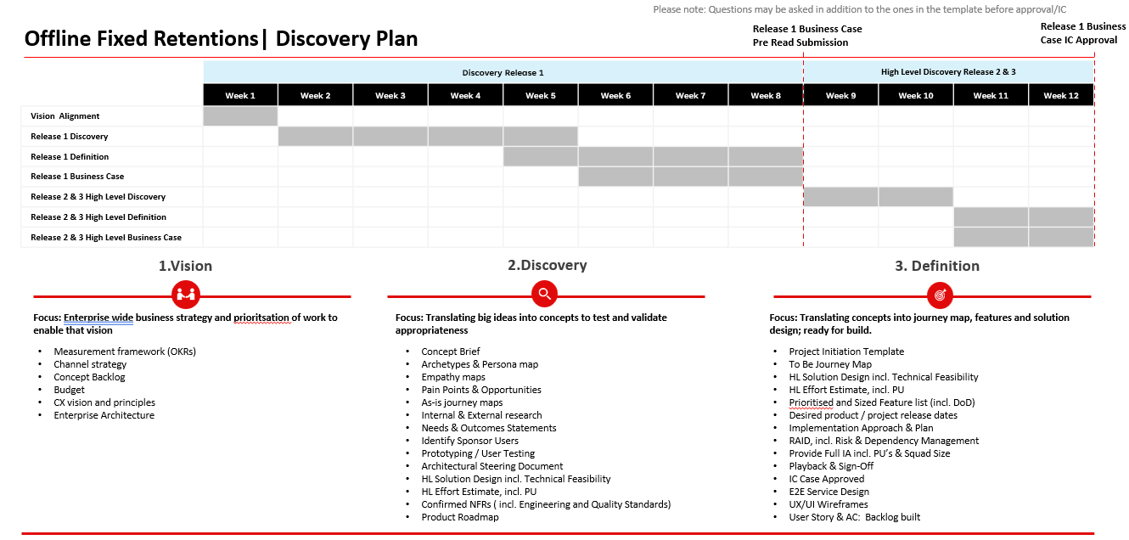
Types of roles/resource profile required to complete these types of activities would usually include:
Resource Type | Supplier/  Internal | Activities | Month 1  (Days) | Month 2  (Days) | Month 3 (Days)
Product Manager | VMO2 | Define product vision, strategy and approach | 20 | 20 | 20
Enterprise Architect | VMO2 | Define E2E architecture | 8 | 8 | 8
Data Architect | VMO2 | Define data architecture | 10 | 10 | 10
Product Owner | GTM | Manage backlog | 20 | 20 | 20
Business Analyst 1 | TCS | Define scope & requirements | 20 | 20 | 20
Business Analyst 2 | TCS | Define scope & requirements |  | 20 | 20
Service Designer | TBC | Define the Personas & E2E user journeys | 20 | 20 | 20
Solution Architect | TCS | Define solution architecture | 20 | 20 | 20
UX/UI Designer | TBC | Design UX/UI wireframes | 10 | 20 | 10
Technical Delivery Lead | TCS | Organising engineering squads & build solution |  | 20
Project Management | TCS | Manage delivery plan / budget | 20 | 20 | 20
Salesforce Technical SMEs x 2 | Accenture | Define high level Salesforce technical solution / impacts |  |  | TBC
Development | TCS | Development, testing & deployment of solution. |  |  | TBC

Overall Project Plan
The business case assumes the following milestones/timelines, to be updated following output from the Vision, Discovery and Definition phases:
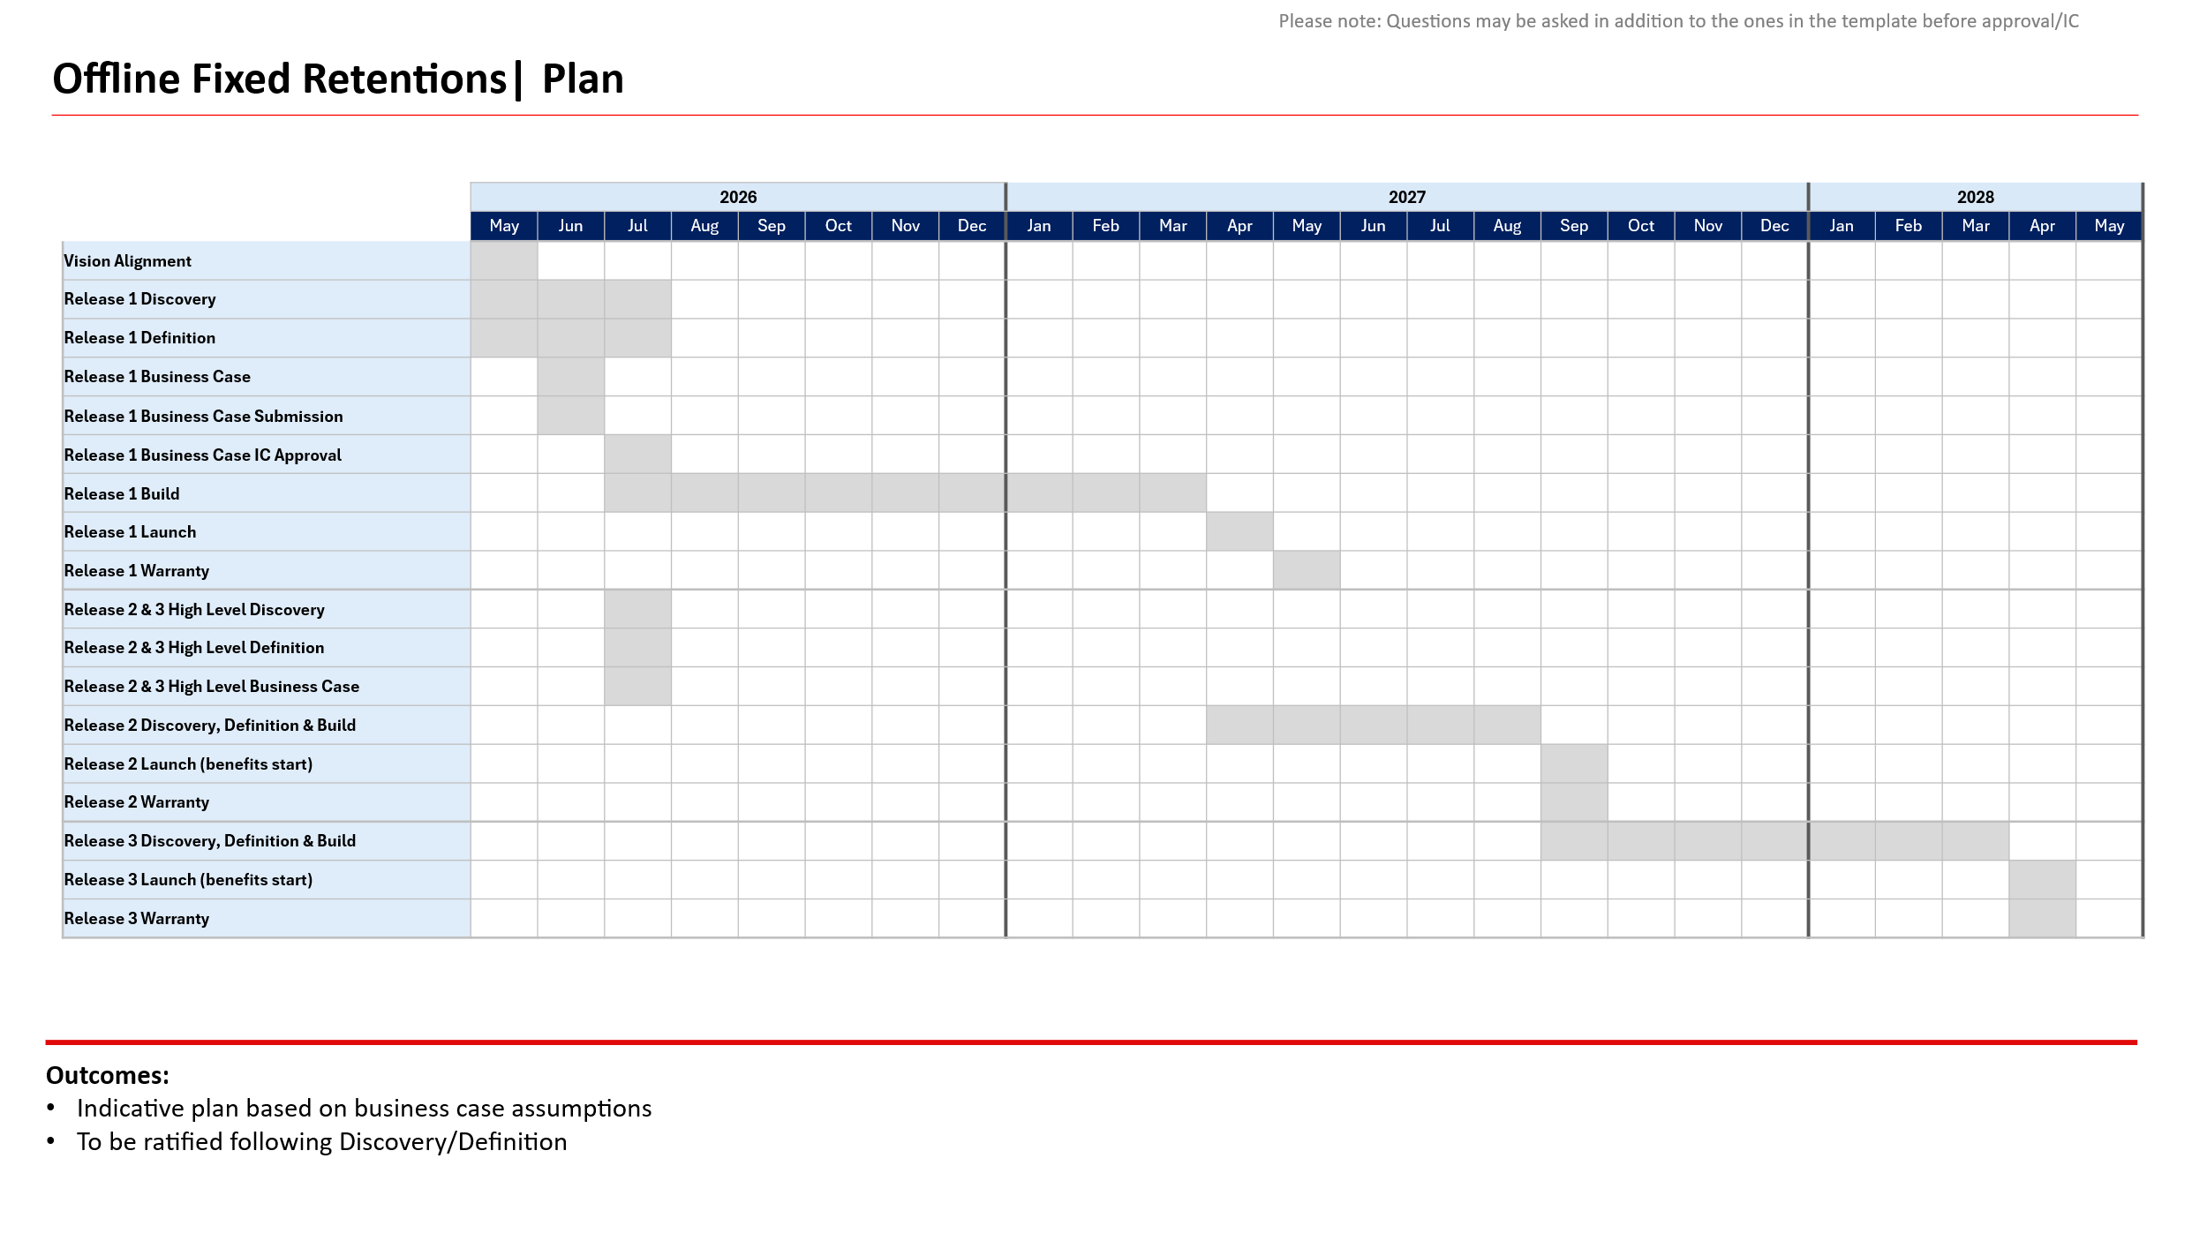

Offline Fixed Transition Architecture
Potential transition architecture on basis Voice is first, transition dependent on Discovery phase and scope agreed for Releases 1-3 and therefore subject to change.
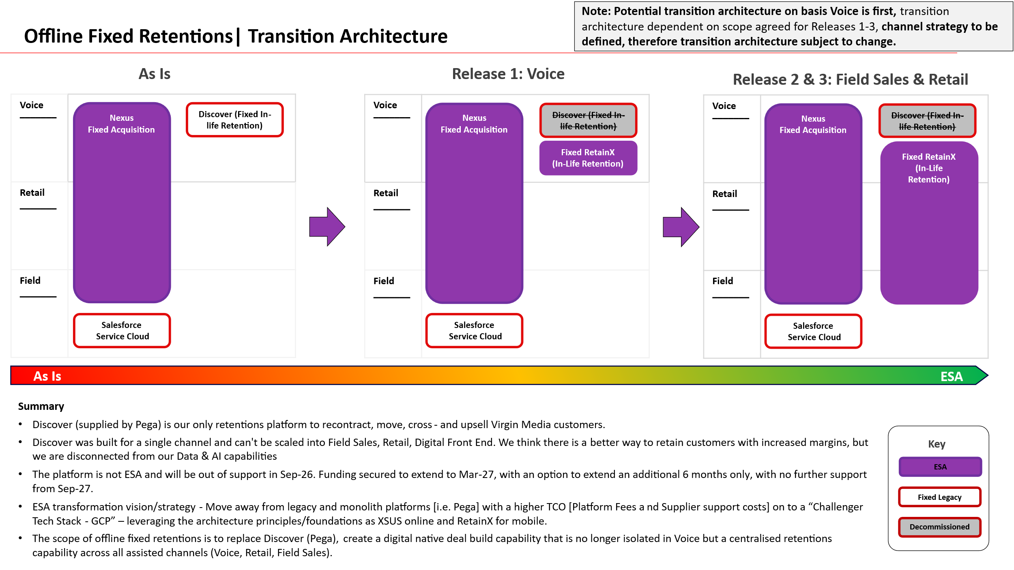

For information: Next steps
- Pre-submission checks: An early conversation with your Business Engagement and Mobilisation (BEM) Partner is advisable. They may suggest a simpler delivery route. They may also be able to support early shaping of your vision around technical capabilities.
- Submission: Once you have a potential sponsor, budget reference and priority from the person or body that prioritises demand in your division, please submit your draft Vision Card to the BEM team [Insert BEM team inbox here]
- Vision card review: A Business Engagement and Mobilisation Partner will engage with you to refine and clarify important details in your vision required to obtain the best early impact assessment. The BEM partner may drive conversations with key architects to ensure we obtain the most cost-effective recommendation ahead of sizing.
- T-Shirt Sizing: When judged fit for purpose, the Vision card will be submitted for platform assessment. This will lead to an initial T-shirt-sizing, and clear ownership of delivery between TCS and TechM.
- Mobilisation: Further mobilisation tasks will depend on funding status, whether the idea is in the baseline plan, and future changes to the delivery quotation process that are TBC with the new delivery suppliers.

